AI - Powered Synthetic Scenario Generator

An IN-HOUSE PROJECT (7CS1900) REPORT

Submitted by

Akshata – 2023BCSE07AED389
Varshini J – 2023BCSE07AED403
Spandana Basava Kulal – 2023BCSE07AED441
Trisha S – 2023BCSE07AED522

In partial fulfilment for the award of the degree of

BACHELOR OF TECHNOLOGY
In
COMPUTER SCIENCE AND ENGINEERING (AIML)

Under the Supervision of

Dr. Saswati Debnath


ALLIANCE SCHOOL OF ADVANCED COMPUTING
ALLIANCE UNIVERSITY, BENGALURU
NOVEMBER - 2026

ABSTRACT

Network intrusion detection plays an important role in identifying malicious activities and protecting computer networks from cyberattacks. However, detecting rare attack categories remains a challenge because network traffic datasets often contain an unequal distribution of attack samples. This class imbalance can affect the ability of machine learning models to identify minority attack categories effectively.
The AI-Powered Synthetic Scenario Generator aims to investigate synthetic data generation as an approach to addressing class imbalance in network intrusion detection. The project uses the UNSW-NB15 dataset, which contains normal network traffic and different categories of cyberattacks. Conditional Tabular Generative Adversarial Networks (CTGAN) are used to generate 500 synthetic samples for the underrepresented Worms attack category. These synthetic samples are combined with the original training data to train a Random Forest classifier. The performance of the model trained using only real data is compared with that of the model trained using real and synthetic data. Accuracy, precision, recall, F1-score, and confusion matrices are used for evaluation.
Experimental results show that synthetic data augmentation increased Worms recall from 0.2500 to 0.3571 and the Worms F1-score from 0.3889 to 0.4878. Overall accuracy increased slightly from 0.9234 to 0.9237, while Worms precision decreased. These findings indicate that synthetic data augmentation can improve the detection of certain minority-class attacks, although trade-offs between precision and recall remain. An interactive Streamlit dashboard is developed to visualize synthetic samples, compare model performance, and present experimental results.
The project demonstrates the potential of synthetic scenario generation for improving minority-class detection in network intrusion detection systems and emphasizes the importance of evaluating model performance using multiple metrics rather than overall accuracy alone.

Keywords: Synthetic Data Generation, CTGAN, UNSW-NB15 Dataset, Network Intrusion Detection, Class Imbalance, Worms Attack Detection, Random Forest Classifier, Machine Learning, Data Augmentation, Streamlit Dashboard.

TABLE OF CONTENTS

CHAPTER NO. | TITLE | PAGE NO.
 | ABSTRACT
 | INTRODUCTION | 4
 | LITERATURE REVIEW | 5-11
 | OBSERVATION FROM THE LITERATURE REVIEW | 12
 | LIMITATIONS OF THE LITERATURE REVIEW | 13
 | PROPSED METHODS | 14-19
 | 5.1 Dataset
 | 5.2 Methods
 | 5.3 Algorithm Used
 | EXPERIMENTATION, RESULT AND ANALYSIS | 20-30
 | 6.1 Experimental Setup
 | 6.2 Performance Metrics
 | 6.3 Results
 | 6.4 Confusion Matrix Analysis
 | 6.4 Ablation Study
 | PERFORMANCE COMPARISION WITH EXISTING TECHNIQUES | 31-32
 | CONCLUSION AND FUTURE SCOPE | 33-34
9. | REFERENCE | 35

- INTRODUCTION

The increasing use of computer networks and internet-based services has made network security essential. Cyberattacks such as denial-of-service, reconnaissance, and other malicious activities pose significant threats to digital systems. Network Intrusion Detection Systems (NIDS) help identify suspicious network traffic and protect systems from potential attacks.
Machine learning techniques are widely used for network intrusion detection. However, their performance can be affected by class imbalance, where common attack categories contain many samples while rare attacks have very few. This can make it difficult for models to identify underrepresented attacks accurately.
The AI-Powered Synthetic Scenario Generator explores synthetic data generation to address this challenge using the UNSW-NB15 dataset. CTGAN is used to generate 500 synthetic samples for the minority Worms attack category. These samples are combined with the original training data, and Random Forest models trained on real-only and augmented datasets are compared using accuracy, precision, recall, and F1-score.
The experimental results show improvements in Worms attack recall and F1-score after synthetic data augmentation, although precision decreases. An interactive Streamlit dashboard is developed to display synthetic samples, visualize evaluation metrics, and compare model performance. The project investigates the potential of synthetic data generation to improve the detection of rare network attacks.

- LITERATURE REVIEW

Research on network intrusion detection has explored various machine learning and deep learning techniques to improve the identification of malicious network activities. Several studies have investigated Generative Adversarial Networks (GANs) for generating synthetic attack data to address class imbalance in network traffic datasets. The paper Network Intrusion Detection Based on Balancing Generative Adversarial Network explores GAN-based data generation to balance attack categories using the UNSW-NB15 dataset. Similarly, Enhancing Autonomous Intrusion Detection System with Generative Adversarial Networks investigates different GAN variants, including CTGAN, for synthetic data generation and intrusion detection.
Other studies have explored knowledge-guided synthetic generation and GAN-based frameworks for improving minority attack detection. KiNETGAN investigates knowledge-infused synthetic network data generation, while research on enhanced AI-based network intrusion detection uses generative models to produce plausible minority-attack traffic. These studies highlight the potential of synthetic data augmentation to improve the representation of underrepresented attack categories. However, some approaches use complex architectures or focus on broader attack distributions rather than specifically targeting a rare attack category.
Research on AI-driven synthetic test data and scenario generation has also demonstrated the use of generative models for producing realistic tabular data and testing scenarios. Other studies have investigated cost-sensitive machine learning, hybrid CNN-LSTM models, reinforcement learning, and conventional machine learning algorithms for network intrusion detection. These approaches provide useful foundations for attack classification and evaluation, although they do not all focus on targeted synthetic data generation for minority attack categories.
Existing research therefore provides a foundation for combining synthetic data generation with machine learning-based intrusion detection. However, the effect of targeted CTGAN-generated samples on the detection of rare Worms attacks requires further investigation within the selected experimental setup. This project addresses this area by using the UNSW-NB15 dataset, generating synthetic Worms samples with CTGAN, and comparing Random Forest models trained on real-only data and real data augmented with synthetic samples. The models are evaluated using accuracy, precision, recall, F1-score, and confusion matrices to assess the impact of synthetic data augmentation on minority-class detection.

Table 1. Literature Review

S.NO | Paper Name | Author Name, Conference, Publication Year | Algorithm Used | Key Methodology | Limitation | Research Gap | How It Helps to Our Project
 | Network Intrusion Detection Based on Balancing Generative Adversarial Network | Yao Meng, Wenshu Zha — 2024 6th International Conference on Artificial Intelligence and Computer Applications (ICAICA) | BAGAN-BD, Autoencoder, Focal Loss, Gradient Penalty | Uses a Balancing GAN to generate attack data and address severe class imbalance. Evaluated on the UNSW-NB15 dataset. | Uses a complex multi-generator architecture and focuses on balancing several attack categories. | Targeted generation of synthetic samples specifically for the most underrepresented attack can be further explored. | Directly supports our UNSW-NB15 → rare attack → synthetic generation → IDS evaluation approach.
 | Enhancing Autonomous Intrusion Detection System with Generative Adversarial Networks | Kevin Kostage, David West, Tim Meinert, Chengyi Qu, Prasad Calyam, Luca Mazzola — 2024 IEEE 20th International Conference on e-Science | WGANGP, CGAN, CTGAN, CWGANGP | Generates synthetic data using different GAN variants and compares GAN-based augmentation with SMOTE and Random Oversampling using accuracy, precision, recall and F1-score. | Multiple GAN models increase computational complexity and training time. | A focused framework for identifying a rare attack and generating only the required synthetic samples can be investigated. | Directly supports our CTGAN selection and our Real-only vs Real+Synthetic experiment.
 | KiNETGAN: Enabling Distributed Network Intrusion Detection through Knowledge-Infused Synthetic Data Generation | Anantaa Kotal, Brandon Luton, Anupam Joshi — 2024 IEEE 44th International Conference on Distributed Computing Systems Workshops (ICDCSW) | Knowledge-Infused GAN (KiNETGAN) | Uses domain knowledge with GANs to generate realistic synthetic network activity while addressing privacy and class-imbalance issues. | Focuses on distributed IoT/CPS environments rather than specifically targeting a rare UNSW-NB15 attack. | Targeted tabular synthetic generation for specific minority attack categories can be explored  . | Supports the concept of realistic synthetic network-data generation and evaluating its usefulness for IDS.
 | AI-Driven Synthetic Test Data and Scenario Generation via GAN-LLM Integration: A Modular Approach for Web Application Testing | Miraç Emektar, Fatih Mehmet Harmancı, Aysun Güran, Berat Karadavut, Günay Kırmızı, Berkay Öztürk, Ata Emir Karamuk, Mert Güven — 2025 10th International Conference on Computer Science and Engineering (UBMK) | LLaMA4, CTGAN, SeqGAN, Selenium | Uses LLaMA4 for semantic extraction, CTGAN for realistic tabular data, and SeqGAN for ordered interaction scenarios. | Designed for web-application testing rather than network intrusion detection and does not use UNSW-NB15. | The AI-driven scenario-generation concept can be adapted to cybersecurity and network-intrusion scenarios. | Highly relevant to our project title “AI-Powered Synthetic Scenario Generator.” It supports AI + synthetic data + scenario generation.
 | An Enhanced AI-Based Network Intrusion Detection System Using Generative Adversarial Networks | Cheolhee Park, Jonghoon Lee, Youngsoo Kim, Jong-Geun Park, Hyunjin Kim, Dowon Hong — IEEE Internet of Things Journal, 2023 | Wasserstein GAN, Autoencoder, Reconstruction Error | Generates plausible synthetic minority-attack traffic using GANs and combines it with autoencoder-based intrusion detection. | The framework is more complex than a basic CTGAN augmentation pipeline and does not specifically focus on automatic rare-class selection. | A simpler targeted CTGAN approach with explicit real-vs-synthetic validation can be explored  . | Strong evidence that GAN-generated minority samples can improve IDS, supporting our central project idea.
 | AE-Multi-WGAN: A Robust Multi-Attack Detection IDS for Imbalanced Datasets | Ishfaq Bashir, Anjali Agarwal, Kuljeet Kaur — 2025 IEEE Global Communications Conference (GLOBECOM) | AutoEncoder + Multi-WGAN | Uses an ensemble AutoEncoder Multi-WGAN to generate synthetic attack samples and improve IDS performance on imbalanced datasets including UNSW-NB15. | Ensemble architecture increases computational and implementation complexity. | A comparatively lightweight CTGAN-based rare-attack augmentation framework can be investigated. | Provides a recent GAN-based benchmark for synthetic-data generation and IDS performance comparison.
 | A Cost-Sensitive Machine Learning Model With Multitask Learning for Intrusion Detection in IoT | Akbar Telikani, Nima Esmi Rudbardeh, Shiva Soleymanpour, Asadollah Shahbahrami, Jun Shen, Georgi Gaydadjiev, Reza Hassanpour — IEEE Transactions on Industrial Informatics, 2024 | Autoencoder + Cost-Sensitive SVM + Multitask Learning | Addresses low-frequency and unknown intrusions using cost-sensitive and multitask learning. Evaluated on UNSW-NB15 and BoT-IoT. | Improves minority detection without generating synthetic data and uses a relatively complex architecture. | Synthetic data generation can be investigated as an alternative/complementary approach for rare attacks. | Provides strong problem justification for rare/low-frequency attacks in our project.
 | Enhanced Network Intrusion Detection Using a Hybrid CNN-LSTM Approach on the UNSW-NB15 Dataset | Zareen Tasnim Pear, Hafsa Binte Kibria — 2024 21st International Conference on Electrical Engineering, Computing Science and Automatic Control (CCE) | CNN + LSTM | Uses a hybrid CNN-LSTM model for binary and multiclass intrusion detection using UNSW-NB15. Evaluates accuracy, precision, recall and F1-score. | Focuses on classification and does not address synthetic-data generation for minority classes. | Synthetic-data augmentation can be combined with IDS classifiers to improve rare-attack detection. | Provides a UNSW-NB15 classification baseline and supports our evaluation metrics.
 | Network Anomaly Detection for Intrusion Detection Systems Using Q-Learning and Deep Q-Learning: A Reinforcement Learning Approach | Adhitama Wichaksono, Parman Sukarno, Aulia Arif Wardana — 2025 IEEE 9th International Conference on Software Engineering & Computer Systems (ICSECS) | Q-Learning, Deep Q-Learning, SMOTE-Tomek | Uses reinforcement learning for adaptive IDS. Uses UNSW-NB15 and simulates zero-day attacks by excluding Fuzzers and Reconnaissance from training. | Focuses on adaptive classification rather than synthetic attack generation. | Synthetic generation could be used to create additional rare or unseen attack scenarios before classification. | Supports our focus on rare/unseen attack scenarios and emphasizes evaluation using unseen data.
 | Intrusion Detection System Based on Machine Learning Techniques: A Survey | Omar I. Sheet, Laheeb Mohammad Ibrahim — 2022 2nd International Conference on Advances in Engineering Science and Technology (AEST) | SVM, Random Forest, Decision Tree, Naïve Bayes, DNN, XGBoost, DBN, ANN | Reviews ML-based intrusion-detection algorithms and datasets including UNSW-NB15, comparing approaches using performance metrics. | Mainly focuses on ML/DL classification and does not deeply investigate GAN-based synthetic data generation. | Integration of synthetic-data generation with ML-based IDS remains an important direction. | Provides the general IDS background and supports using classifiers such as Random Forest in our experiment.

- OBSERVATIONS FROM THE LITERATURE REVIEW

The following observations were made from the reviewed research papers:
- Use of Machine Learning: Several studies use machine learning algorithms such as Random Forest, SVM, Decision Trees, and deep learning models for network intrusion detection.
- Synthetic Data Generation: Multiple papers explore GAN-based techniques to generate synthetic attack samples and address class imbalance.
- Use of UNSW-NB15 Dataset: Several reviewed studies use the UNSW-NB15 dataset to evaluate intrusion detection methods.
- Importance of Rare Attack Detection: The reviewed research highlights the difficulty of detecting attack categories with fewer training samples.
- Different Data Balancing Techniques: Researchers explore methods such as GAN variants, SMOTE, and random oversampling to improve the representation of minority classes.
- Model Evaluation: Accuracy, precision, recall, and F1-score are commonly used to evaluate intrusion detection performance.
- Need for Practical Approaches: The reviewed studies suggest the value of exploring simpler synthetic data generation methods and measuring their effect on classification performance.
Based on these observations, our project focuses on generating additional samples for the rare Worms attack category and comparing Random Forest performance before and after augmentation.

- LIMITATIONS OF THE LITERATURE REVIEW
The reviewed papers have some limitations and areas that require further investigation:
- High Computational Requirements: Some GAN-based approaches use complex architectures that may require more computing resources and training time.
- Focus on Specific Methods: Several studies concentrate on particular algorithms or network environments, which may limit their direct applicability to other settings.
- Limited Focus on Individual Rare Attacks: Not all reviewed studies specifically focus on generating samples for the rare Worms category in UNSW-NB15.
- Quality of Synthetic Samples: Increasing the number of training samples does not necessarily guarantee that the generated records are realistic or useful for classification.
- Need for Performance Comparison: The effect of synthetic data augmentation needs to be measured by comparing model performance before and after adding synthetic samples.
- Further Validation Required: Additional experiments are needed to understand how different generation techniques affect rare attack detection and overall classification performance.
Based on these limitations, our project uses perturbation-based sampling to generate additional Worms records and compares the results of Random Forest models trained with and without augmentation. The approach provides a simple way to study the effect of synthetic samples, although further testing is needed to establish their quality and general usefulness.

5. PROPOSED METHODS
The proposed system presents an AI-powered pipeline for generating synthetic network attack scenarios and evaluating their effectiveness in network intrusion detection. It uses the UNSW-NB15 dataset and CTGAN to generate synthetic samples for the underrepresented Worms attack category. The generated samples are combined with the original training data and evaluated using a Random Forest classifier. This section describes the data preprocessing, synthetic data generation, model training, evaluation process, and proposed system architecture.

Table 2. Summary of Network Intrusion Detection Methodologies, Findings, Advantages, and Limitations
Scheme | Key Finding | Advantage | Disadvantage
GAN-based network intrusion detection | Uses GAN-generated attack samples to address class imbalance. | Improves representation of minority attack classes. | Generated samples may not fully represent real attack traffic.
CTGAN-based synthetic data generation | Generates synthetic tabular records while learning feature distributions. | Suitable for structured network traffic data. | Training can be computationally expensive.
Knowledge-guided GAN | Incorporates domain knowledge into synthetic network data generation. | Can produce more meaningful synthetic samples. | May require additional domain knowledge and model complexity.
Random Forest intrusion detection | Classifies network traffic using multiple decision trees. | Provides a useful baseline and supports multiclass classification. | May struggle to detect rare attacks when training data is imbalanced.
Synthetic data augmentation | Combines generated samples with real training data. | Can improve minority-class recall. | May reduce precision or introduce unrealistic patterns.
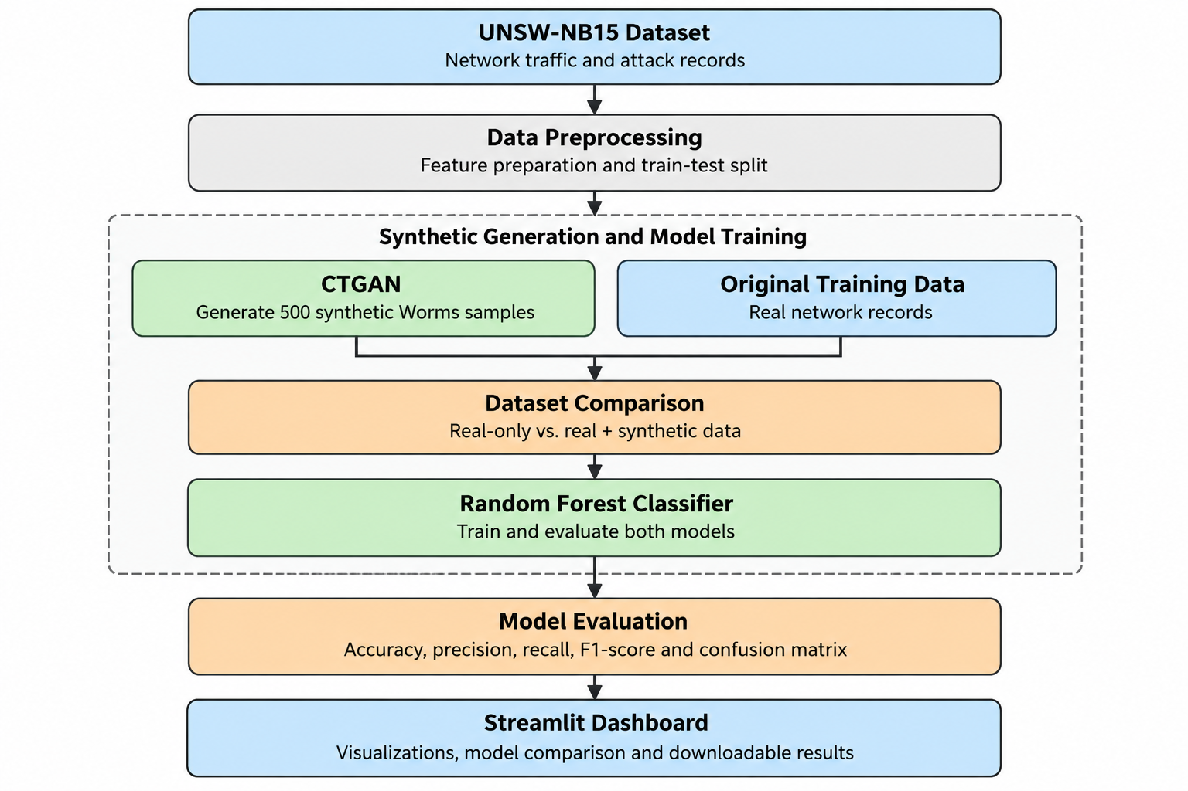
Fig. 1. Proposed architecture of the AI-Powered Synthetic Scenario Generator.

5.1 Dataset
This project utilizes the publicly available UNSW-NB15 dataset for network intrusion detection. The dataset contains normal network traffic and multiple categories of network attacks, including Worms, which is the minority class targeted in this project. The dataset is used to investigate the impact of synthetic data generation on the detection of underrepresented attacks. The data is divided into training and testing sets to train the classification models and evaluate their performance on unseen records. In the current experiment, the training set contains 114,679 records, while the test set contains 28,670 records.

5.1.1 Data Preprocessing and Augmentation
Data preprocessing and augmentation are performed to prepare the network traffic records for model training. The following steps are applied:
- Data Loading: The UNSW-NB15 training and testing datasets are loaded for processing and evaluation.
- Feature Preparation: The input features and target attack labels are separated for classification.
- Class Imbalance Identification: The Worms attack category is identified as an underrepresented class in the training data.
- Synthetic Data Generation: CTGAN is used to generate 500 synthetic Worms samples to increase the representation of the minority class.
- Dataset Augmentation: The generated samples are combined with the original training data, increasing the training dataset from 114,679 to 115,179 records.
- Testing: The original test set is retained for evaluating both models, allowing a consistent comparison between real-only and augmented training data.

5.2 Methods
The proposed system uses a synthetic data generation and machine learning pipeline to investigate the detection of minority network attacks. CTGAN generates synthetic samples for the underrepresented Worms attack category, and Random Forest classifiers are used to compare performance before and after data augmentation.
- Data Preprocessing Module: Loads the UNSW-NB15 dataset, prepares the input features and target labels, and separates the training and testing data.
- Synthetic Data Generation Module: Uses Conditional Tabular Generative Adversarial Networks (CTGAN) to generate 500 synthetic Worms attack samples from the training data.
- Dataset Augmentation Module: Combines the generated synthetic samples with the original training dataset to increase the representation of the minority attack category.
- Random Forest Classification Module: Trains two classifiers: one using only real training data and another using real training data augmented with synthetic samples.
- Model Evaluation Module: Evaluates both classifiers using accuracy, precision, recall, F1-score, and confusion matrices on the same test dataset.
- Streamlit Dashboard Module: Presents the synthetic samples, evaluation metrics, model comparisons, and experimental results through an interactive interface.

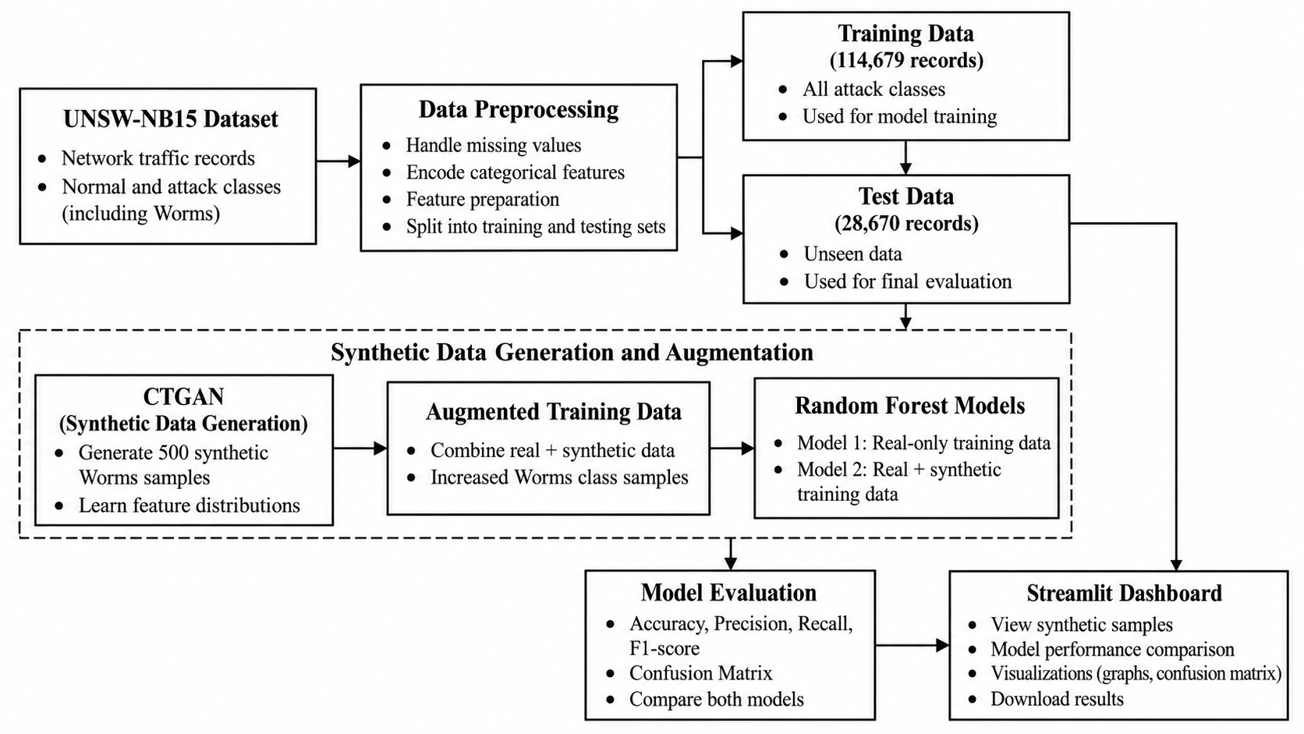
Fig. 2. Proposed methodology of the AI-Powered Synthetic Scenario Generator

5.3 Algorithms Used
- Conditional Tabular Generative Adversarial Network (CTGAN)
CTGAN is used to generate synthetic network traffic records for the underrepresented Worms attack category in the UNSW-NB15 dataset. It learns patterns and feature distributions from tabular data and generates 500 synthetic samples to increase the representation of the minority class in the training dataset.
- Random Forest Classifier
Random Forest is used to classify network traffic into different attack categories. It combines the predictions of multiple decision trees to produce a final classification. Two models are trained and compared: one using the original training dataset and another using the augmented dataset containing real and synthetic samples.

- Performance Evaluation
The trained models are evaluated using accuracy, precision, recall, and F1-score. Confusion matrices are also used to examine classification performance. Particular attention is given to Worms attack recall and F1-score to determine whether synthetic data augmentation improves minority-class detection.

5.3.1 Working
The working process is as follows:
1. Load the UNSW-NB15 dataset and identify the Worms attack records.
- Select existing Worms records for synthetic sample generation.
- Apply small perturbations to selected continuous features to create additional records.
- Prepare the augmented training dataset.
- Train and evaluate a Random Forest model using the original training data and compare it with the model trained using the augmented data.
- Compare the evaluation metrics to observe whether augmentation improves classification performance.
- Display the results through the Streamlit dashboard.

6. Experimentation, Results and Analysis
The experiments are conducted using the UNSW-NB15 dataset to evaluate the effectiveness of CTGAN-based synthetic data augmentation for minority-class network attack detection. The generated synthetic samples are combined with the original training data, and Random Forest classifiers are evaluated using the same test dataset. The experimental results are analysed using accuracy, precision, recall, F1-score, and confusion matrices.

6.1 Experimental Setup
The experiment uses 114,679 real training records and 28,670 test records. CTGAN is
used to generate 500 synthetic samples belonging to the Worms attack category. These samples are added to the original training dataset, increasing its size to 115,179 records. Two Random Forest classifiers are trained: a baseline model using only real training data and an augmented model using both real and synthetic data.

The experimental setup is summarized below:
- Dataset: UNSW-NB15
- Synthetic Data Generation: Conditional Tabular Generative Adversarial Network (CTGAN)
- Synthetic Samples: 500 Worms attack records
- Classification Algorithm: Random Forest
- Baseline Training Data: 114,679 real records
- Augmented Training Data: 115,179 records
- Test Data: 28,670 records
- Evaluation Metrics: Accuracy, precision, recall, F1-score, and confusion matrix
Both models are evaluated on the same test dataset to ensure a fair comparison. Particular attention is given to Worms-class recall and F1-score because the project focuses on improving the detection of underrepresented attacks.
Table 3. Experimental Configuration of the Proposed System
Parameter | Value
Dataset | UNSW-NB15
Synthetic Data Generation | CTGAN
Target Attack Category | Worms
Synthetic Samples Generated | 500
Original Training Records | 114,679
Augmented Training Records | 115,179
Test Records | 82,332
Classification Algorithm | Random Forest
Baseline Model | Real training data only
Augmented Model | Real + synthetic training data
Evaluation Strategy | Same held-out test set

Attack Category Distribution
The attack category distribution highlights the class imbalance present in the UNSW-NB15 training dataset. The Worms category contains only 130 records, substantially fewer than the majority classes. This imbalance can limit the model's ability to learn minority-class patterns effectively. Therefore, CTGAN is used to generate synthetic Worms samples to investigate whether additional training data can improve minority-class detection.

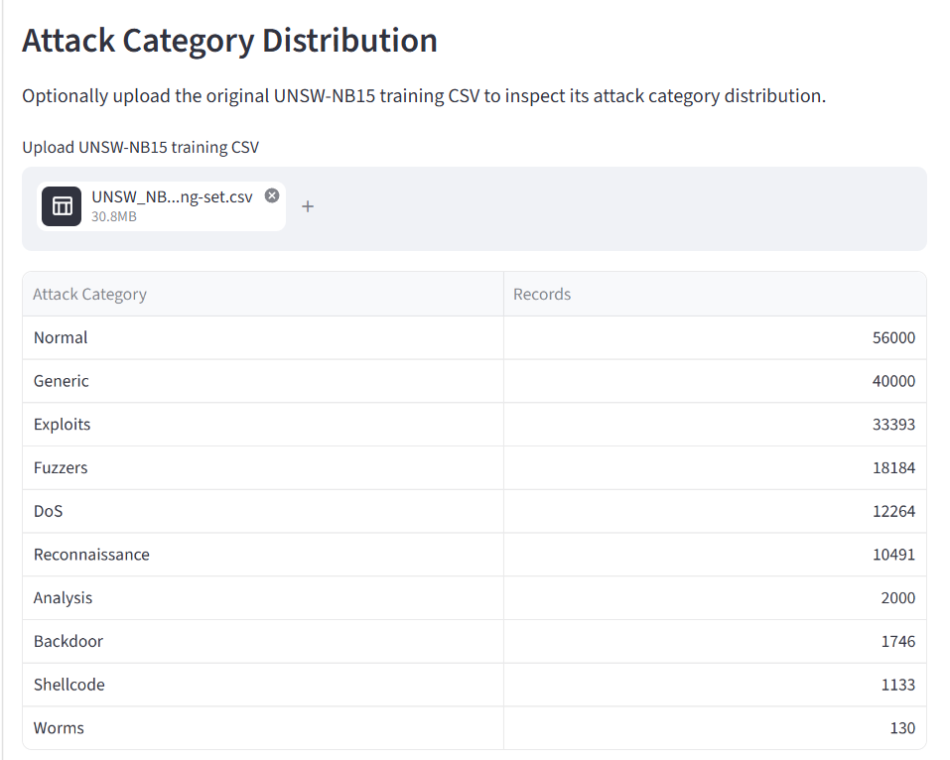

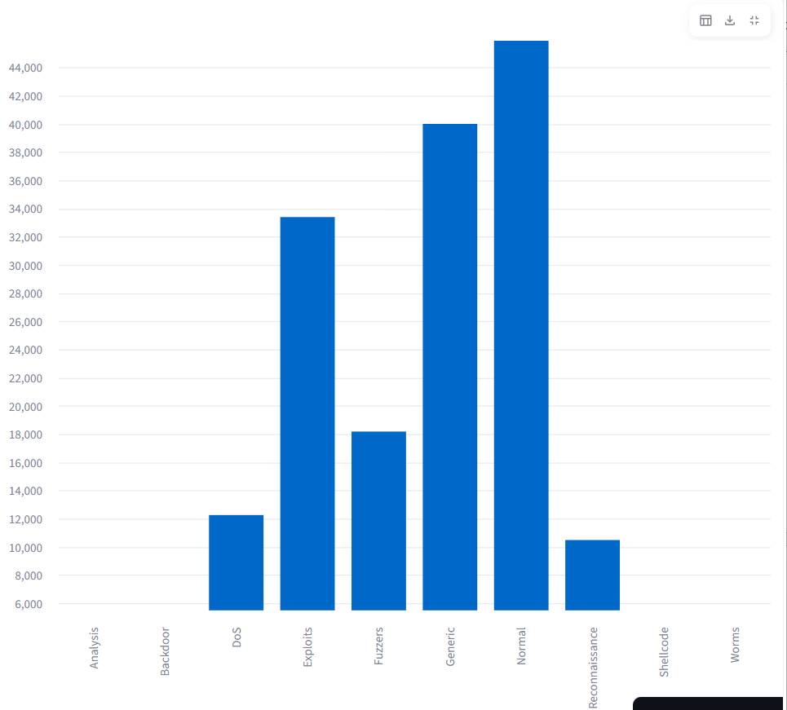

Fig. 3. Class distribution of the UNSW-NB15 training dataset.

6.2 Performance Metrics
To evaluate the effectiveness of the proposed system, standard classification metrics are used to compare the Random Forest model trained on real data with the model trained on real and synthetic data. These metrics provide insights into overall classification performance and the ability to detect the minority Worms attack category.

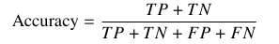
Accuracy: Measures the proportion of correctly classified records among all test records.

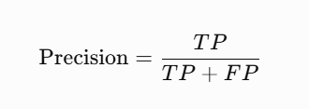
Precision: Measures the proportion of predicted positive samples that are correctly classified.

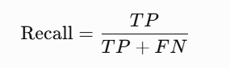
Recall: Measures the proportion of actual positive samples correctly identified by the model. This metric is particularly important for evaluating Worms attack detection.

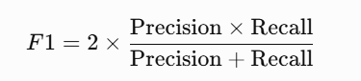
F1-score: Represents the harmonic mean of precision and recall, providing a balanced measure of their performance.

Macro F1-score: Calculates the F1-score independently for each attack category and then averages the results equally across all classes. It helps assess performance when the dataset has imbalanced class distributions.
Weighted F1-score: Computes the average F1-score across classes while accounting for the number of actual samples in each class.
Confusion Matrix: Summarizes the actual and predicted class labels, showing correctly classified and misclassified records for each attack category.
These metrics are used to determine whether CTGAN-based synthetic data augmentation improves minority-class detection without significantly reducing overall classification performance.

6.3 Results
This section presents the experimental results of the proposed AI-Powered Synthetic Scenario Generator. The performance of the Random Forest classifier trained on real data is compared with that of the classifier trained on real and CTGAN-generated synthetic data. Both models are evaluated on the same test dataset using accuracy, precision, recall, and F1-score.
The real-only model achieved an accuracy of 92.34%, while the augmented model achieved 92.37%. After synthetic data augmentation, Worms attack recall increased from 25.00% to 35.71%, and the Worms F1-score improved from 38.89% to 48.78%. However, Worms precision decreased from 87.50% to 76.92%.
The results indicate that synthetic data augmentation improved the model's ability to identify Worms attacks, although this improvement involved a reduction in precision. The weighted F1-score increased slightly from 0.9219 to 0.9220, while the macro F1-score increased from 0.4960 to 0.5043. These findings suggest that the overall classification performance remained relatively stable while minority-class detection improved.
The results demonstrate the potential of CTGAN-generated synthetic samples to improve the detection of underrepresented network attacks. However, further evaluation is required to determine whether these improvements remain consistent across different data splits and experimental settings.

Table 4. Comparison of Random Forest Classification Performance
Metric | Real-only RF | Real + Synthetic RF
Accuracy | 0.9234 | 0.9237
Worms Precision | 0.875 | 0.7692
Worms Recall | 0.25 | 0.3571
Worms F1-score | 0.3889 | 0.4878
Weighted F1-score | 0.9219 | 0.9220
Macro F1-score | 0.4960 | 0.5043

Table 5. Additional Performance Metrics for Real-Only and Augmented Models
Metric | Real-only RF | Real + Synthetic RF
Weighted F1-score | 0.9219 | 0.9220
Macro F1-score | 0.4960 | 0.5043
Worms Recall | 0.2500 | 0.3571
Worms F1-score | 0.3889 | 0.4878
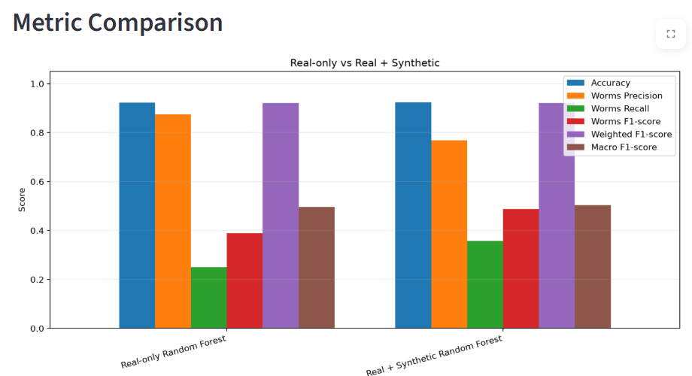

Fig. 4. Performance comparison between the real-only and synthetic-augmented Random Forest models.
The graph compares the performance of the Random Forest classifier before and after CTGAN-based synthetic data augmentation. Worms recall increases from 0.2500 to 0.3571, while the Worms F1-score improves from 0.3889 to 0.4878. Overall accuracy remains nearly unchanged, increasing from 0.9234 to 0.9237. However, Worms precision decreases from 0.8750 to 0.7692. These results indicate improved detection of minority-class attacks, with a trade-off in precision.
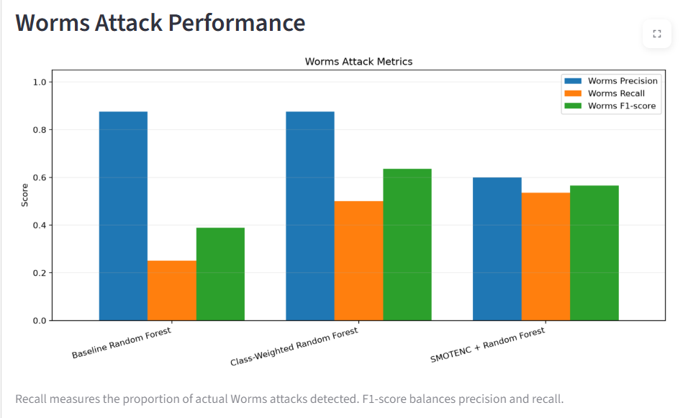

Fig. 5. Worms attack precision, recall, and F1-score comparison across baseline Random Forest models.

Figure 5 compares Worms attack detection performance across the Baseline Random Forest, Class-Weighted Random Forest, and SMOTENC-based Random Forest models. The baseline model achieves high precision but low recall, indicating that it identifies Worms attacks accurately when detected but misses many actual instances. The class-weighted model improves recall and F1-score, while the SMOTENC-based model provides a more balanced performance across precision, recall, and F1-score. These results highlight the importance of evaluating minority-class metrics rather than relying solely on overall accuracy.

6.4 Confusion Matrix Analysis
The confusion matrices are used to examine the classification performance of the Baseline Random Forest, Class-Weighted Random Forest, and SMOTENC Random Forest models across the UNSW-NB15 attack categories. The diagonal elements represent correctly classified samples, while the off-diagonal elements indicate misclassifications between attack categories.
The matrices show that classification performance varies across attack categories. Common classes such as Normal and Generic have relatively high numbers of correct predictions, whereas minority classes, including Worms, have fewer correctly classified samples. This highlights the difficulty of detecting underrepresented attacks in an imbalanced dataset.
The confusion matrices provide a class-wise view of model performance and help identify misclassification patterns. For the proposed CTGAN-based augmentation experiment, a separate confusion matrix comparison between the real-only and real-plus-synthetic Random Forest models is needed to directly assess the effect of synthetic data generation on Worms attack detection.
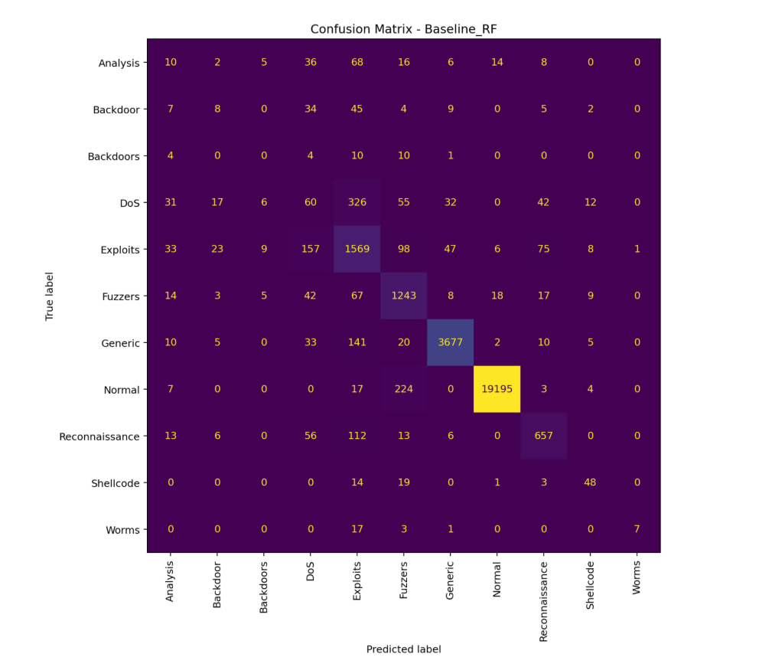

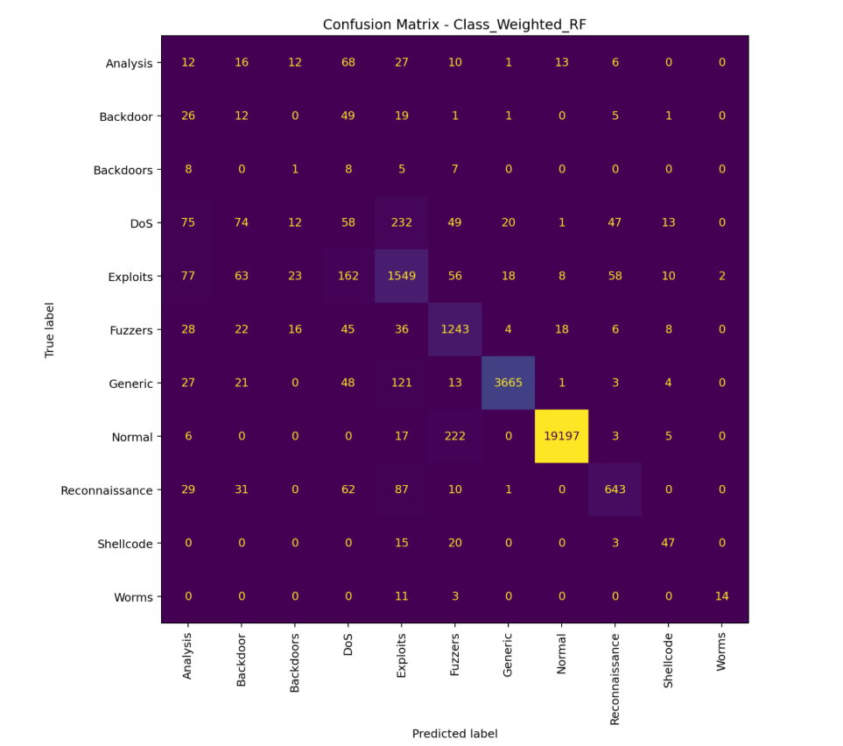

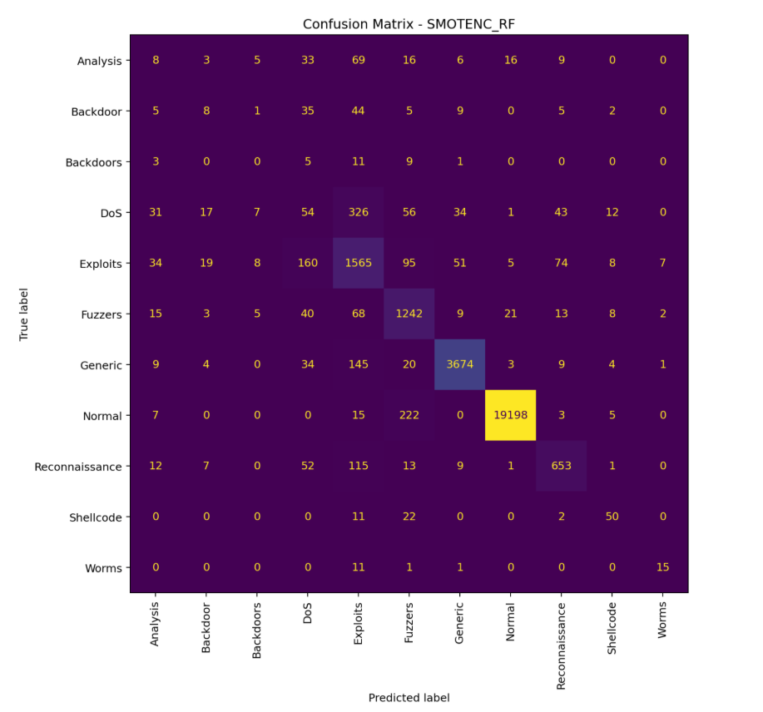

Fig. 6. Confusion matrices of the Baseline, Class-Weighted, and SMOTENC Random Forest models.

6.5 Ablation Study
An experimental comparison was conducted to examine the contribution of different data-balancing strategies to network intrusion detection using the UNSW-NB15 dataset. The experiments compare the Baseline Random Forest, Class-Weighted Random Forest, SMOTENC Random Forest, and the proposed CTGAN-based synthetic data augmentation approach.
The Baseline Random Forest serves as the reference model trained on real data. The Class-Weighted Random Forest addresses class imbalance by assigning different weights to attack categories, while SMOTENC applies synthetic oversampling to the training data. The proposed approach generates additional minority-class Worms samples using CTGAN and combines them with real training records before training the Random Forest classifier.
The purpose of this study is to examine whether targeted CTGAN-based data augmentation improves the detection of underrepresented Worms attacks while maintaining overall classification performance.

Table 6. Comparison of Data-Balancing Approaches
Model configuration | Accuracy | Macro F1-score | Worms Recall | Worms F1-score
Baseline Random Forest | 0.9234 | 0.4960 | 0.250 | 0.3889
Class-Weighted Random Forest | 0.9223 | 0.5209 | 0.5 | 0.6364
SMOTENC Random Forest | 0.9232 | 0.5113 | 0.5357 | 0.5660
Real + Synthetic Random Forest | 0.9237 | 0.5043 | 0.3571 | 0.4878

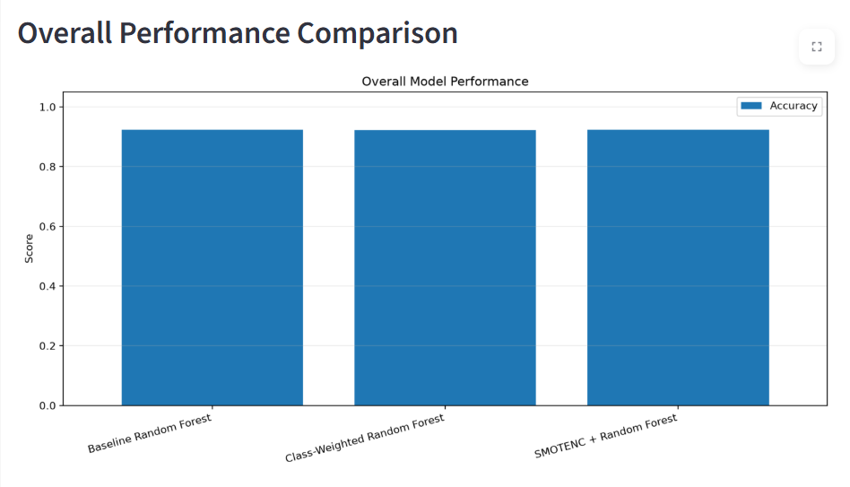
Fig. 6. Overall accuracy comparison of Random Forest models using different data-balancing approaches.

The graph compares the overall accuracy of the baseline, class-weighted, and SMOTENC-based Random Forest models. The results show that their overall accuracy values are similar. Since accuracy alone may not adequately represent performance on highly imbalanced datasets, additional metrics such as Worms recall, Worms F1-score, and macro F1-score are considered to evaluate minority-class detection. The proposed CTGAN-based augmentation approach is assessed using these metrics to determine its effectiveness in identifying underrepresented network attacks.

7. Performance Comparison with Existing Techniques
To evaluate the effectiveness of the proposed AI-Powered Synthetic Scenario Generator, its performance is compared with existing network intrusion detection methods reported in the literature. Previous studies have explored oversampling techniques, class-imbalance-aware classification, and hybrid deep learning architectures using the UNSW-NB15 dataset. In this study, particular emphasis is placed on detecting the minority Worms attack category, which is challenging because of its limited representation in the training data. The proposed approach uses CTGAN to generate synthetic Worms attack samples and incorporates them into the training dataset to improve minority-class detection. Table 8 presents a quantitative comparison of selected existing methods with the baseline Random Forest and the proposed CTGAN-augmented Random Forest model.

Table 7. Quantitative Comparison with Existing Methods for Network Intrusion Detection on the UNSW-NB15 Dataset
Study / Method | Methodology | Accuracy | Worms Precision | Worms Recall | Worms F1-score
Random Forest with SMOTE[1] | SMOTE + Random Forest | 95.10 | ___ | ___ | ___
Class-Imbalance-Aware RF[2] | Class-balanced Random Forest | 75.97 | ___ | ___ | ___
TransNET[3] | Hybrid deep Learning model | ___ | ___ | ___ | 0.6471
Real-only RF(Baseline | Random Forest trained on real data | 92.34 | 0.8750 | 0.2500 | 0.3889
Propsed Method | CTGAN + Random Forest | 92.37 | 0.7692 | 0.3571 | 0.4878

Note: “—” indicates that the corresponding metric was not available in the reviewed results. Since existing studies may use different data splits, preprocessing techniques, and evaluation settings, their results are presented as reference benchmarks rather than direct head-to-head comparisons.

As shown in Table 7, the proposed CTGAN-augmented Random Forest model achieves an accuracy of 92.37%, compared with 92.34% for the real-only baseline model. More importantly, Worms recall increases from 25.00% to 35.71%, while the Worms F1-score improves from 0.3889 to 0.4878. These results indicate that synthetic data augmentation improves the model's ability to identify minority-class Worms attacks, although the improvement in overall accuracy is marginal. The Worms F1-score also remains below the value reported by the TransNeSt study, indicating scope for further improvement. Since the existing studies may differ in dataset splits, preprocessing methods, and evaluation settings, their reported results should be interpreted as reference benchmarks rather than direct comparisons. Overall, the findings suggest that CTGAN-based augmentation can improve minority-class detection in the proposed experimental setting.

- Conclusion and Future Scope
This study presents an AI-Powered Synthetic Scenario Generator for addressing class imbalance in network intrusion detection using the UNSW-NB15 dataset. The proposed approach employs Conditional Tabular Generative Adversarial Networks (CTGAN) to generate synthetic samples for the underrepresented Worms attack category. The generated samples are combined with real training data, and a Random Forest classifier is evaluated before and after augmentation.
The experimental results show that the accuracy of the Random Forest model increased from 92.34% to 92.37% after synthetic data augmentation. More importantly, Worms attack recall improved from 25.00% to 35.71%, while the Worms F1-score increased from 0.3889 to 0.4878. These findings indicate that CTGAN-based augmentation improved the model's ability to identify minority-class Worms attacks in the evaluated setting. However, the improvement in overall accuracy was marginal, and Worms precision decreased from 87.50% to 76.92%. Therefore, synthetic data augmentation improved some minority-class metrics but did not improve every performance measure.
Overall, the study demonstrates the potential of targeted synthetic data generation to improve minority-class detection in network intrusion detection systems. Further experimentation is required to improve the quality of generated samples and establish more consistent performance gains across evaluation metrics.
Future Scope
Several improvements can be explored in future work. First, alternative synthetic data generation techniques, including CTGAN variants, Conditional GANs, and Wasserstein GANs, can be evaluat
ed to identify methods that generate more realistic network traffic records. Second, synthetic sample quality can be improved through feature-range constraints, domain-specific validation, and statistical similarity analysis to reduce unrealistic or invalid feature values.
Third, the proposed approach can be evaluated using different augmentation ratios and hyperparameter configurations to determine the optimal number of synthetic Worms samples. Fourth, additional classification algorithms, such as XGBoost, LightGBM, and class-weighted Random Forest, can be investigated to improve minority-class precision, recall, and F1-score. Future experiments should also examine per-class confusion matrices, macro F1-score, and repeated stratified evaluations to provide a more comprehensive assessment.
Finally, the framework can be extended to other rare attack categories in the UNSW-NB15 dataset and tested on additional intrusion detection datasets. Integrating the trained model into a real-time network monitoring environment could further assess its practical applicability, computational efficiency, and ability to detect evolving network threats.

9. REFERENCES

- Y. Meng and W. Zhao, “Network Intrusion Detection Based on Balancing Generative Adversarial Network,” ICAICA, 2024.
- K. Kostage, D. West, T. Meinert, C. Qu, and P. Calyam, “Enhancing Autonomous Intrusion Detection System with Generative Adversarial Networks,” IEEE e-Science, 2024.
- A. Kotal, B. Luton, and A. Joshi, “KiNETGAN: Enabling Distributed Network Intrusion Detection through Knowledge-Infused Synthetic Data Generation,” ICDCSW, 2024.
- C. Park et al., “An Enhanced AI-Based Network Intrusion Detection System Using Generative Adversarial Networks,” IEEE Internet of Things Journal, 2023.
- I. Bashir, A. Agarwal, and K. Kaur, “AE-Multi-WGAN: A Robust Multi-Attack IDS for Imbalanced Datasets,” IEEE GLOBECOM, 2025.
- O. I. Sheet and L. M. Ibrahim, “Intrusion Detection System Based on Machine Learning Techniques: A Survey,” AEST, 2022.
- UNSW Canberra, “The UNSW-NB15 Dataset.” Available: https://research.unsw.edu.au/projects/unsw-nb15-dataset
- Scikit-learn, “RandomForestClassifier Documentation.” Available: https://scikit-learn.org/stable/modules/generated/sklearn.ensemble.RandomForestClassifier.html
- Streamlit, “Streamlit Documentation.” Available: https://docs.streamlit.io/

